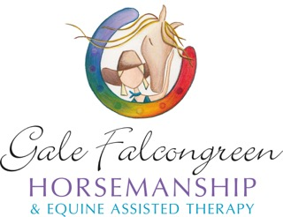
Student Information Form

Student Consent Form

(First name and surname)

OR

As a Parent/Person with legal responsibility for the student:

(please note this is for students under 18 years old)

(Child’s first name and surname)

I,

(Your first name and surname)

give my consent for the abovementioned student to participate in Gale Falcongreen Horsemanship & Equine Assisted Therapy as detailed in the written information supplied to me. I am aware of the nature of the activity and agree to delegate my authority to the staff and instructors involved.

I accept that the teachers and instructors will take appropriate disciplinary action necessary to ensure the safety, well-being and successful conduct of the students who participate in the activities associated with the excursion.

In the event of any illness or accident, I authorise the obtaining of such medical assistance as required. I accept all responsibility for payment of any expenses thus incurred.

I include the completed medical information section (below) to assist.

Signed: Date:

(Student/Person with legal responsibility)

Emergency contact and telephone number:

Medical Information: (Please note - Where * is used, please delete as appropriate)

Does the student have any medical condition or disability which may affect participation? Yes/No* If Yes, please give details:

Is the student on any prescribed medication(s)? Yes/No* If Yes, please give details:

Does the student have any allergies (e.g. insect bites, food)? Yes/No* If Yes, please give details:

Is there any other information you would like to give which, in your view, may affect the student’s participation? Yes/No* If Yes, please give details:

